CREATE TABLE DRUG

(

DrugId INT(100) NOT NULL,

DrugCoatingType VARCHAR(100) NOT NULL,

DrugName VARCHAR(100) NOT NULL,

PRIMARY KEY (DrugId)

);

CREATE TABLE INGREDIENT

(

IngredientName VARCHAR(100) NOT NULL,

IngredientId INT(100) NOT NULL,

PRIMARY KEY (IngredientId)

);

CREATE TABLE NURSE

(

NurseId INT(100) NOT NULL,

NurseName VARCHAR(100) NOT NULL,

PRIMARY KEY (NurseId)

);

CREATE TABLE COMPANY

(

PlantZipCode INT(100) NOT NULL,

DateAndTime VARCHAR(100) NOT NULL,

DateOfProduce INT(100) NOT NULL,

CompanyId INT(100) NOT NULL,

ConsumeWithin INT(100) NOT NULL,

PRIMARY KEY (CompanyId)

);

CREATE TABLE ALLERGY

(

AllergyID INT(100) NOT NULL,

AllergyName VARCHAR(100) NOT NULL,

PRIMARY KEY (AllergyID)

);

CREATE TABLE Contains

(

Dosage INT(100) NOT NULL,

DrugId INT(100) NOT NULL,

IngredientId INT(100) NOT NULL,

PRIMARY KEY (DrugId, IngredientId),

FOREIGN KEY (DrugId) REFERENCES DRUG(DrugId),

FOREIGN KEY (IngredientId) REFERENCES INGREDIENT(IngredientId)

);

CREATE TABLE manufacturedBy

(

DrugId INT(100) NOT NULL,

CompanyId INT(100) NOT NULL,

PRIMARY KEY (DrugId, CompanyId),

FOREIGN KEY (DrugId) REFERENCES DRUG(DrugId),

FOREIGN KEY (CompanyId) REFERENCES COMPANY(CompanyId)

);

CREATE TABLE CanBeTaken

(

DrugId_1 INT(100) NOT NULL,

CanBeTakenDrugId_2 INT(100) NOT NULL,

PRIMARY KEY (DrugId_1, CanBeTakenDrugId_2),

FOREIGN KEY (DrugId_1) REFERENCES DRUG(DrugId),

FOREIGN KEY (CanBeTakenDrugId_2) REFERENCES DRUG(DrugId)

);

CREATE TABLE PATIENT

(

PatientId INT(100) NOT NULL,

PatientBDate VARCHAR(100) NOT NULL,

PatientGender VARCHAR(100) NOT NULL,

PatientFName VARCHAR(100) NOT NULL,

PatientLName VARCHAR(100) NOT NULL,

AllergyID INT(100),

PRIMARY KEY (PatientId),

FOREIGN KEY (AllergyID) REFERENCES ALLERGY(AllergyID)

);

CREATE TABLE DRUGINTAKE

(

DinNumber INT(100) NOT NULL,

DinTime INT(100) NOT NULL,

DinDate DATE NOT NULL,

PatientId INT(100) NOT NULL,

NurseId INT(100) NOT NULL,

PRIMARY KEY (DinNumber, PatientId),

FOREIGN KEY (PatientId) REFERENCES PATIENT(PatientId),

FOREIGN KEY (NurseId) REFERENCES NURSE(NurseId)

);

CREATE TABLE Includes

(

Quantity INT(100) NOT NULL,

DrugId INT(100) NOT NULL,

DinNumber INT(100) NOT NULL,

PatientId INT(100) NOT NULL,

PRIMARY KEY (DrugId, DinNumber, PatientId),

FOREIGN KEY (DrugId) REFERENCES DRUG(DrugId),

FOREIGN KEY (DinNumber, PatientId) REFERENCES DRUGINTAKE(DinNumber, PatientId)

);

CREATE TABLE IsAllergic

(

PatientID INT NOT NULL,

AllergyID INT NOT NULL,

PRIMARY KEY (PatientID, AllergyID)

);

CREATE TABLE Administrator

(

NurseID INT NOT NULL,

DinNumber INT NOT NULL,

PRIMARY KEY (NurseID, DinNumber)

);

CREATE TABLE Receives

(

PatientID INT NOT NULL,

DinNumber INT NOT NULL,

PRIMARY KEY (PatientID, DinNumber)

);

INSERT INTO ALLERGY VALUES(1110,'Antibiotics');

INSERT INTO ALLERGY VALUES(1118,'Penicillin');

INSERT INTO ALLERGY VALUES(1113,'Ibuprofen');

INSERT INTO ALLERGY VALUES(1114,'Anticonvulsants');

INSERT INTO ALLERGY VALUES(1115,'Nyquil');

INSERT INTO ALLERGY VALUES(1116,'Carbamazepine');

INSERT INTO ALLERGY VALUES(1117,'Topiramate');

INSERT INTO ALLERGY VALUES(0000,'None');

INSERT into PATIENT VALUES(2000,'MARCH 2 1985','Male','Mark','Walhberg',0000);

INSERT into PATIENT VALUES(2001,'Jan 8 2003','Male','Mark','Walhberg',1118);

INSERT into PATIENT VALUES(2002,'MARCH 3 1999','Male','Max','Pattinson',1113);

INSERT into PATIENT VALUES(2003,'August 4 1998','Male','Akhilesh','Gowda',0000);

INSERT into PATIENT VALUES(2004,'Jun 2 1988','Female','Rebecca','Sims',1117);

INSERT into PATIENT VALUES(2005,'Feb 4 2005','Female','Allegra','Harvey',1115);

INSERT into PATIENT VALUES(2006,'Dec 26 2000','female','Julia','Wanchic',1116);

INSERT into PATIENT VALUES(2007,'Nov 2 1985','Female','Emma','Watson',1113);

INSERT into PATIENT VALUES(2008,'Sept 23 1989','Male','John','Cena',1114);

INSERT into PATIENT VALUES(2009,'July 2 1996','Male','Harry','Henderson',1110);

INSERT into PATIENT VALUES(2010,'Oct 31 1960','Male','Arnold','Walhberg',1118);

INSERT into PATIENT VALUES(2011,'MARCH 2 1985','Female','Julia','Roberts',1114);

INSERT into PATIENT VALUES(2012,'Aug 3 1981','Female','Sandra','Bullock',1116);

INSERT INTO DRUG VALUES(3000,'Aqueous Film','Tylenol');

INSERT INTO DRUG VALUES(3001,'Sugar','hydroxyzine');

INSERT INTO DRUG VALUES(3002,'Solvent Based','Hydrocodone');

INSERT INTO DRUG VALUES(3003,'Liquid','Nyquil');

INSERT INTO DRUG VALUES(3004,'Aqueous Film','Escitalopram');

INSERT INTO DRUG VALUES(3005,'White Film','Antibiotic');

INSERT INTO DRUG VALUES(3006,'Sugar','Penicillin');

INSERT INTO DRUG VALUES(3007,'Gelatin','Ibuprofen');

INSERT INTO DRUG VALUES(3008,'Sugar','Anticonvulsants');

INSERT INTO DRUG VALUES(3009,'Solvent Based','Carbamazepine');

INSERT INTO DRUG VALUES(3010,'White Film','Topiramate');

INSERT INTO DRUG VALUES(3011,'Non Gelatin','Diphenhydranine HCL');

INSERT INTO INGREDIENT VALUES('Water',4000);

INSERT INTO INGREDIENT VALUES('Magnesium',4001);

INSERT INTO INGREDIENT VALUES('Carbonic Acid',4002);

INSERT INTO INGREDIENT VALUES('Zinc',4003);

INSERT INTO INGREDIENT VALUES('Phospate',4004);

INSERT INTO INGREDIENT VALUES('Iron',4005);

INSERT INTO INGREDIENT VALUES('Sodium',4006);

INSERT INTO INGREDIENT VALUES('Bicarbonate',4007);

INSERT INTO INGREDIENT VALUES('Sulfate',4008);

INSERT INTO INGREDIENT VALUES('Chlorine',4009);

INSERT INTO COMPANY VALUES (47408,'May 24 2022 6:15PM','August 5',5000,' August 4 2023');

INSERT INTO COMPANY VALUES (47409,'June 22 2022 6:15PM','August 4',5002,' December 8 2023');

INSERT INTO COMPANY VALUES (57409,'July 3 2021 5:30PM','September 4',5003,' December 9 2023');

INSERT INTO COMPANY VALUES (57405,'March 8 2021 7:15PM','July 23',5004,' December 9 2024');

INSERT INTO COMPANY VALUES (57406,'Jan 14 2020 7:30PM','July 24',5005,' December 9 2024');

INSERT INTO COMPANY VALUES (77407,'March 10 2021 7:15PM','July 23',5006,' December 10 2024');

INSERT INTO COMPANY VALUES (77405,'March 11 2021 7:15PM','July 29',5007,' December 9 2025');

INSERT INTO COMPANY VALUES (87408,'July 11 2021 7:15PM','July 29',5008,' December 9 2026');

INSERT INTO Contains VALUES (5,3000,4000);

INSERT INTO Contains VALUES (15,3001,4001);

INSERT INTO Contains VALUES (55,3002,4002);

INSERT INTO Contains VALUES (34,3004,4003);

INSERT INTO Contains VALUES (40,3005,4004);

INSERT INTO Contains VALUES (43,3006,4006);

INSERT INTO Contains VALUES (23,3007,4005);

INSERT INTO Contains VALUES (33,3008,4007);

INSERT INTO Contains VALUES (66,3009,4009);

INSERT INTO Contains VALUES (12,3010,4008);

INSERT INTO Contains VALUES (67,3011,4004);

INSERT INTO manufacturedBy VALUES(3000,5000);

INSERT INTO manufacturedBy VALUES(3001,5002);

INSERT INTO manufacturedBy VALUES(3002,5003);

INSERT INTO manufacturedBy VALUES(3003,5004);

INSERT INTO manufacturedBy VALUES(3004,5005);

INSERT INTO manufacturedBy VALUES(3005,5006);

INSERT INTO manufacturedBy VALUES(3006,5007);

INSERT INTO manufacturedBy VALUES(3007,5008);

INSERT INTO manufacturedBy VALUES(3008,5006);

INSERT INTO manufacturedBy VALUES(3009,5002);

INSERT INTO manufacturedBy VALUES(3010,5000);

INSERT INTO manufacturedBy VALUES(3011,5003);

INSERT into CanBeTaken VALUES(3000,3001);

INSERT into CanBeTaken VALUES(3001,3000);

INSERT into CanBeTaken VALUES(3003,3002);

INSERT into CanBeTaken VALUES(3002,3003);

INSERT into CanBeTaken VALUES(3008,3009);

INSERT into CanBeTaken VALUES(3009,3008);

INSERT into CanBeTaken VALUES(3005,3006);

INSERT into CanBeTaken VALUES(3005,3007);

INSERT into CanBeTaken VALUES(3007,3006);

INSERT into CanBeTaken VALUES(3004,3006);

INSERT into CanBeTaken VALUES(3006,3001);

INSERT INTO DRUGINTAKE VALUES(8000,'6PM','May 21 2021',2000,1);

INSERT INTO DRUGINTAKE VALUES(8001,'7PM','Jan 2 2022',2001,2);

INSERT INTO DRUGINTAKE VALUES(8002,'7AM','April 22 2022',2002,3);

INSERT INTO DRUGINTAKE VALUES(8003,'9PM','May 1 2022',2003,5);

INSERT INTO DRUGINTAKE VALUES(8004,'5PM','Jan 11 2022',2004,4);

INSERT INTO DRUGINTAKE VALUES(8005,'2AM','Dec 24 2022',2005,6);

INSERT INTO DRUGINTAKE VALUES(8006,'1PM','Oct 12 2022',2006,7);

INSERT INTO DRUGINTAKE VALUES(8007,'8PM','Nov 27 2022',2007,8);

INSERT INTO DRUGINTAKE VALUES(8008,'6AM','Sept 4 2022',2008,9);

INSERT INTO DRUGINTAKE VALUES(8009,'6PM','July 7 2022',2009,10);

INSERT INTO DRUGINTAKE VALUES(8010,'4PM','Feb 3 2022',2010,11);

INSERT INTO DRUGINTAKE VALUES(8011,'3PM','August 4 2022',2011,12);

INSERT INTO DRUGINTAKE VALUES(8012,'9AM','June 26 2022',2012,13);

INSERT INTO Includes VALUES(3,3000,8000,2000);

INSERT INTO Includes VALUES(1,3004,8001,2001);

INSERT INTO Includes VALUES(2,3011,8002,2002);

INSERT INTO Includes VALUES(3,3010,8003,2003);

INSERT INTO Includes VALUES(5,3009,8004,2004);

INSERT INTO Includes VALUES(1,3008,8005,2005);

INSERT INTO Includes VALUES(55,3007,8006,2006);

INSERT INTO Includes VALUES(6,3006,8007,2007);

INSERT INTO Includes VALUES(4,3005,8008,2008);

INSERT INTO Includes VALUES(2,3004,8009,2009);

INSERT INTO Includes VALUES(7,3003,8010,2010);

INSERT INTO Includes VALUES(9,3002,8011,2011);

INSERT INTO Includes VALUES(4,3001,8012,2012);

INSERT INTO NURSE VALUES(1, “Amy”);

INSERT INTO NURSE VALUES(2, “Cassidy”);

INSERT INTO NURSE VALUES(3, “Lorian”);

INSERT INTO NURSE VALUES(4, “Sims”);

INSERT INTO NURSE VALUES(5, “Jack”);

INSERT INTO NURSE VALUES(6, “Cadee”);

INSERT INTO NURSE VALUES(7, “Becky”);

INSERT INTO NURSE VALUES(8, “Calie”);

INSERT INTO NURSE VALUES(9, “Natalie”);

INSERT INTO NURSE VALUES(10, “Brownen”);

INSERT INTO NURSE VALUES(11, “Therase”);

INSERT INTO NURSE VALUES(12, “Pete”);

INSERT INTO NURSE VALUES(13, “Adam”);

INSERT INTO NURSE VALUES(14, “Steve”);

INSERT INTO NURSE VALUES(15, “Joane”);

INSERT INTO IsAllergic VALUES(2000,118);

INSERT INTO IsAllergic VALUES(2004,113);

INSERT INTO IsAllergic VALUES(2008,115);

INSERT INTO Administrator VALUES(1, 2001);

INSERT INTO Administrator VALUES(3, 2005);

INSERT INTO Administrator VALUES(5, 2009);

INSERT INTO Receives VALUES(2002, 8000);

INSERT INTO Receives VALUES(2004, 8002);

INSERT INTO Receives VALUES(2008, 8011);

INSERT INTO Receives VALUES(2010, 8012);

Queries:

1. Selecting the patient id, firstname and last name and his allergies

Select p.PatientId,p. PatientFName, p.PatientLName, a.AllergyName

From ALLERGY a, PATIENT p

Where a.AllergyID = p.AllergyID;

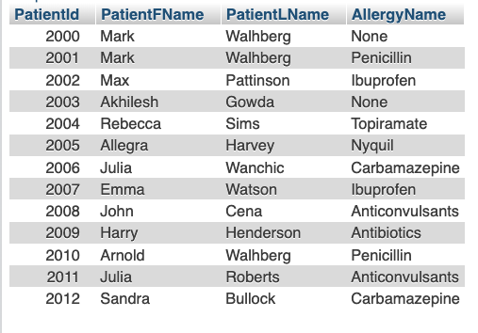

Q.2. Selecting the patient id, firstname and last name having an allergy to Ibuprofen

Select p.PatientId,p. PatientFName, p.PatientLName, a.AllergyName

From ALLERGY a, PATIENT p

Where a.AllergyID = p.AllergyID and a.AllergyName = 'Ibuprofen';

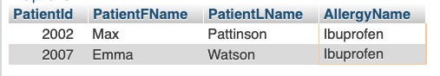

Q.3 selecting all the patients who are not allergic to ‘Nyquil’ by making use of Minus

SELECT PatientId,PatientFName,PatientLName

from PATIENT p LEFT JOIN ALLERGY USING(AllergyID) where AllergyName<>'Nyquil';

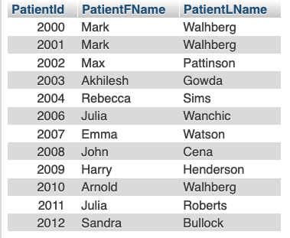

Q.4 patient and their nurses

SELECT p.PatientId, p.PatientFName,n.NurseName

FROM DRUGINTAKE d, NURSE n, PATIENT p

WHERE n.NurseId = d.NurseId and p.PatientId = d.PatientId;

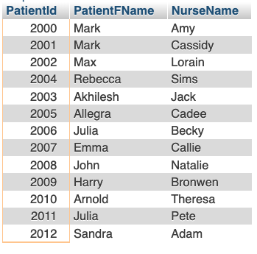

Q.5 company id , Drug name and ingredient name

SELECT c.CompanyId, d.DrugName, i.IngredientName

FROM COMPANY c, manufacturedBy m, DRUG d, Contains co, INGREDIENT i

WHERE m.DrugId = d.DrugId and c.CompanyId = m.CompanyId and co.DrugId = d.DrugId and i.IngredientId = co.IngredientId;

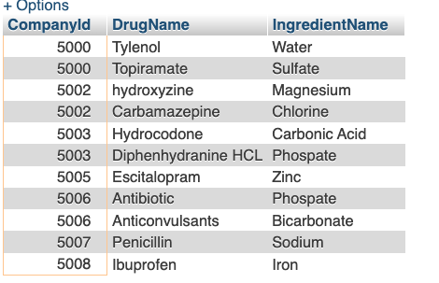

Q.6 Number of patients with Allergy

SELECT DISTINCT COUNT(p.PatientId) AS PatientsWithAllergy

FROM PATIENT p, ALLERGY a

WHERE p.AllergyID = a.AllergyID and a.AllergyName <>'None'

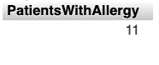

Q.7 companies manufacturing more than one type of drugs

SELECT m.CompanyId,COUNT(m.DrugId) as NumberOfDrugs

FROM manufacturedBy m

GROUP by m.CompanyId

HAVING NumberOfDrugs>1;

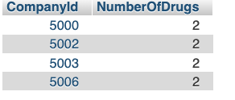

Q.8 patient information for the drug taken by patient which has been manufactured by company id 5000

SELECT i.PatientId , p.PatientFName

FROM Includes i, PATIENT p

WHERE p.PatientId = i.PatientId and EXISTS( SELECT 1

FROM manufacturedBy m

where m.DrugId = i.DrugId and m.CompanyId = '5000');

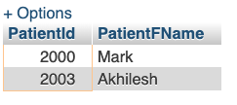

Q.9 Risk calculation for drugs

SELECT DrugId,CASE WHEN Dosage <25 THEN 'Safe to Consume'

WHEN Dosage >25 and Dosage <50 THEN 'Moderate Risk'

WHEN Dosage >50 THEN 'Highly Risky' END AS RiskTye

FROM Contains;

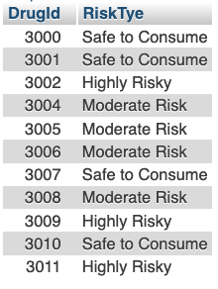

Q.10 Joining multiple tables and fetching the drug name where Ingredient Name is “Carbonic Acid”.

SELECT D.DrugName, I.IngredientName FROM DRUG D

JOIN Contains C ON D.DrugId = C.DrugId

JOIN INGREDIENT I ON I.IngredientId = C.IngredientId

WHERE I.IngredientName = "Carbonic Acid";

Q 11 Using union, we try to get patient name, and allergy name.

SELECT PatientFName FROM PATIENT

UNION

SELECT AllergyName FROM ALLERGY

